Available online at www.sciencedirect.com


ScienceDirect

IFAC-PapersOnLine 49-1 (2016) 178–182

Terrain Based D* Algorithm for Path Planning

C. Saranya¹, Manju Unnikrishnan², S. Akbar Ali³, D. S. Sheela⁴
and Dr. V.R. Lalithambika⁵
¹Scientist/Engineer, SCG, ISRO Satellite Centre, India
²Deputy Division Head, CGFSD, Vikram Sarabhai Space Centre, India
³Division Head, CGFSD, Vikram Sarabhai Space Centre, India

⁴Group Director, Control and Guidance Design Group, Vikram Sarabhai Space Centre, India ⁵Deputy Director, Control Guidance and Simulation Entity, Vikram Sarabhai Space Centre, India

Abstract - Path planning algorithms provide autonomy in mobile robots to reach targets even in unknown environments. Path planning using grid based techniques such as A* and D*, are cost function based, which is primarily a function of the distance to be travelled to reach the target. Robots targeted for outdoor environments should consider the terrain features also during path planning. In this paper, a modified approach of D* path planning algorithm is proposed. In addition to distance to be travelled, terrain slope estimate is also used in cost function computation to plan the path. The algorithm was simulated and tested with different terrain slopes. Results with different test scenarios are also brought out.

© 2016, IFAC (International Federation of Automatic Control) Hosting by Elsevier Ltd. All rights reserved.

Index Terms — Terrain based Path planning, D* algorithm

- INTRODUCTION

discarded as obstacles. Marshy and slippery terrains are also to be avoided to prevent wheel slippage.

Terrain Ruggedness index (TRI) gives the amount of elevation difference between the adjacent cells. Based on the range of TRI, the level of ruggedness can be determined. Based on the level of ruggedness, level or nearly level regions can be identified for path planning.

In this paper a modified version of D* algorithm is presented where cost function computation also involves terrain based factors. In addition to the distance to be travelled, a factor based on 3D slope of the terrain is included in the cost function computation.

The algorithm was simulated in C and tested for different terrain slopes. Following is the categorization of the Paper: Section II describes the modified D* algorithm for terrain based path planning. Section III describes the Simulation while Section IV discusses the results. And Section V gives the conclusion.

Mobile robots are supplemented with Path Planning algorithms to enable them to reach target autonomously. Several techniques are available in literature for path planning. Steven M.LaValle(2006) gives an overview on various approaches to Path Planning. Grid based techniques such as A* and D* algorithms are classical methods of path planning. These algorithms reach the target in shortest path, provided path is available. Takayuki Goto et al (2003), briefs on the Heuristics of A* algorithm. GopiKrishnan et al (2011) gives a comparison of different path planning techniques. Y. Koren et al (1991) & Jorge Nieto et al (2010) deal with other approaches to Path Planning.

Grid based algorithms plan the path based on cost functions. Cost functions are based on distance to be travelled to reach the target point. For even-terrain environments distance to be travelled will be the deciding factor for path planning. However for outdoor environments especially un-even terrains, nature of terrain will also play a major role. The effort spent by the rover while climbing up or down an un-even region has to be accounted in addition to the linear distance to be travelled.

Also additional terrain features can be included to make the path planning more efficient. Genya Ishigami et al (2011) & Xie Yuan et al (2010) discuss on approaches to terrain based path planning. For instance nature of the terrain can also be used to determine the regions which are traversable by the rover. Rocky regions can be

II. MODIFIED D* ALGORITHM FOR TERRAIN
BASED PATH PLANNING

D* algorithm is a grid based approach. Ref 8 & Ref 9 give the overview of D* algorithm and its applications. The area of exploration is split into n x n grid. Each cell in the grid has a state to denote the presence or absence of obstacles. The basic cost function of D* is based on distance to be travelled. As the region to be explored is split into squares, the cost involved in moving along and

across the cell is the same. Moving to the diagonal cell requires additional cost. Let ‘p’ be the cost of moving

horizontally or vertically in the cell. Then cost function is given in equation 1

Cost(x,y)hor|ver = p * units
Cost(x,y)diag = (√2 * p) * units | (1)

The above cost function is modified to include a factor based on the terrain slope. The slope of terrain and its azimuth is computed from 3D points.

Consider two points A(x1,y1,z1) and B(x2,y2,z2). The slope between the points A and B is computed as per equation 2. The azimuth (in degrees) or the orientation angle measured clockwise from North is given in equation 3

Slope = (z2-z1) / √ ((x2-x1) ^2 + (y2-y1) ^2) | (2)

2405-8963 © 2016, IFAC (International Federation of Automatic Control) Hosting by Elsevier Ltd. All rights reserved. Peer review under responsibility of International Federation of Automatic Control.

10.1016/j.ifacol.2016.03.049

C. Saranya et al. / IFAC-PapersOnLine 49-1 (2016) 178–182 | 179

Azimuth = (180 / ∏) tan⁻¹ ((x2-x1)/(y2-y1)) | (3)

Cost function of D* algorithm is modified as per equation 4 to accommodate a term based on the terrain slope. The factor in the equation can be tuned based on different terrains.

Cost_Function = Cost(x,y) + abs(slope) * Fact | (4)

Ascending a slope is given a higher factor compared to descending. For moving across a level terrain factor is made zero. The cost of moving vertically or horizontally in a cell of size 40 cms is taken as 10 units. The cost of moving diagonally is assumed to be 14 units. Factor for ascending is assumed to be 20 while for descending it is taken as 10.

If ascending

Fact = 20

Else if descending

Fact = 10

Else

Fact = 0

End If
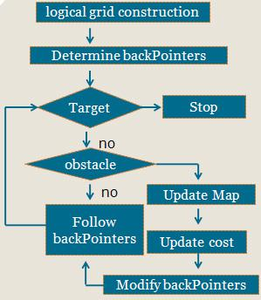

Figure 1: D* algorithm

Based on the above equations, cost functions are computed for all the cells. Rover moves through the cells which have the least cost functions. The flowchart of the algorithm is given in Figure 1.

Figure 2: States of Rover
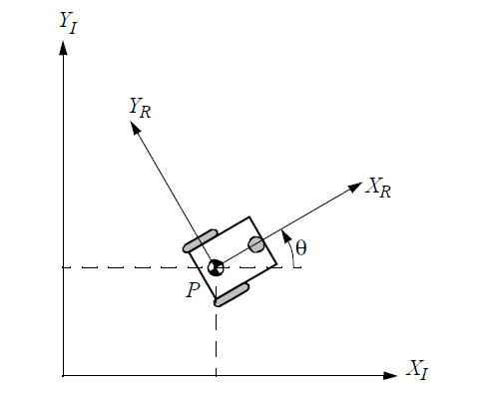
- SIMULATION

Modified D* algorithm for Terrain based path planning was implemented in C.

An ideal rover was assumed. Cost functions computed based on the terrain information of the adjacent cells is used to identify the cell with the minimum cost function. Rover then moves to the chosen cell.

During experimentation each cell was assumed to be of 40 x 40 cms. The cell size could be decided based on the dimensions of the actual rover. It could be planned in such a way that rover will be confined within a cell at any point of time.

The location of the rover can be described with three states(x, y, θ) at any instant as in Figure 2. The orthogonal rotational matrix to map the rover’s motion

from global reference frame to its local reference frame is given in equation 5.

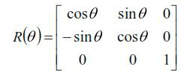(5)

Since rover can move to only one of its adjacent eight cells, it has eight possible orientations as in Figure 3.
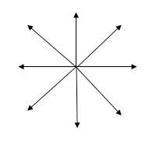

Figure 3: Eight possible orientations of rover as it moves to adjacent cell

180 C. Saranya et al. / IFAC-PapersOnLine 49-1 (2016) 178–182

The position and orientation of the rover is controlled by commanding the servos of the wheels. When a rover, which does not have the capability to move laterally, has to move to a cell to its left or right, it first orients to the required direction and then moves forward.

The current position and orientation of rover is estimated by accumulating the wheel encoder measurements. For one rotation of the wheel the distance traversed by the rover is given in equation 6

Dist = 2*pi*r | (6)

where, r is the radius of the wheel.

Let p denote the encoder value corresponding to one full rotation i.e encoder reading required for moving by distance, Dist as in equation 6. Then encoder measurement, p1, for moving the rover by a distance of Dist1 units, would be as in equation 7

p1 = p* Dist1 / Dist | (7)

Based on equation 7 the reference encoder value is generated for each movement.

IV. RESULTS

Table 1 shows the height of the each cells, of the grid considered, along with X and Y co-ordinates. The Rover has to start at the cell 10 and reach the target 13.

If the cost of moving 4 cm is taken as 1 unit, then for moving along (vertically / horizontally) a cell of 40cms, cost involved is 10 units and the cost of moving diagonally is 14 units. Cost function computed based on the distance to be travelled is given in Table 2.

Path traced by the Rover using D* algorithm is given in Figure 5. Since slope of the terrain is not included in cost function computation path is not optimal.
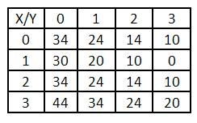

Table 2: Cost function computed based on D*

Modified D* algorithm was implemented in C and tested in ideal rover condition. Two typical cases are elaborated below. Test case 1 is a 4x4 grid where each cell occupies 40cmx40cm as in Figure 4.
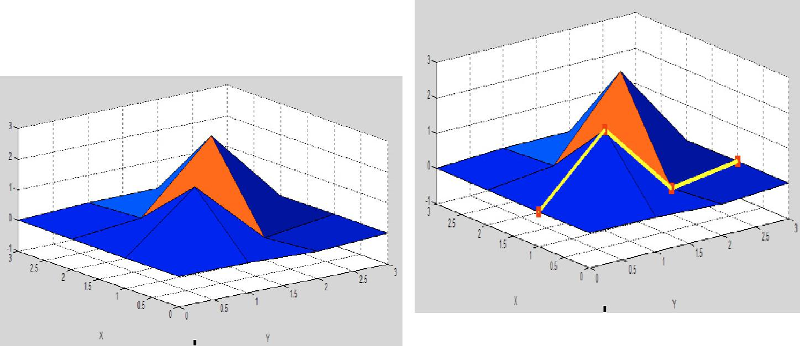

 | Figure 5: Path traced by Rover using D* algorithm
Figure 4: Terrain considered – Test case 1 | Cost function computed using the modified D*
 | algorithm involving the slope of the terrain is given in
 | Table 3.
 | Path traced by the rover using the modified D*
 | algorithm is given in Figure 6. Though shortest path
 | based on distance is through cells 10->11->12->13, since
 | there is a peak in cell 11, rover reaches the targes
 | through cells 10->01->12->13.
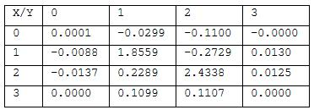

Table 1: Height of cells

C. Saranya et al. / IFAC-PapersOnLine 49-1 (2016) 178–182 | 181
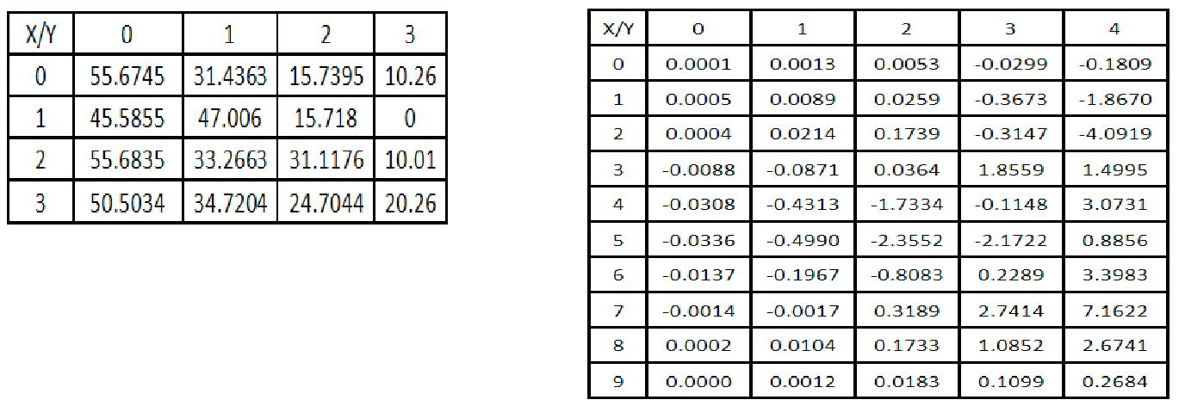

Table 3: Cost function computed based on Modified D*

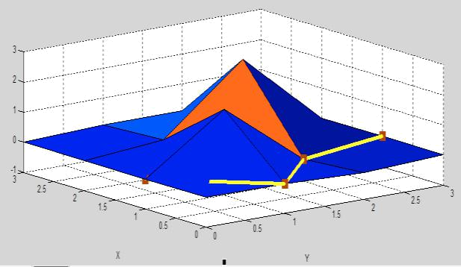

Table 4: Height of cells 00 to 94
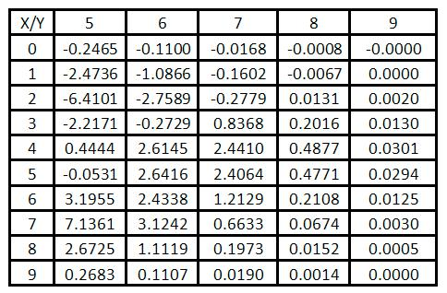

Figure 6: Path traced by Rover using Modified D* algorithm

Table 5: Height of cells 50 to 99
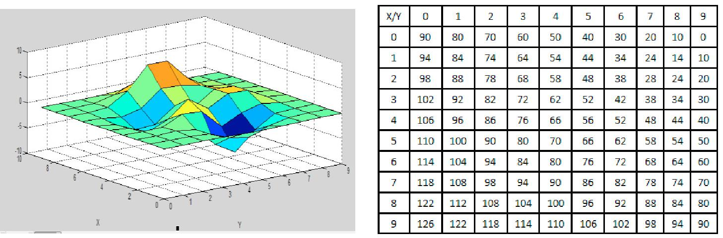

Figure 7: Terrain considered – Test case 2 | Table 6: Cost function computed based on D*

Another test case with 10 x 10 grid as in Figure 7, is elaborated below. The height of each cell is given in Tables 4 & 5. The rover has to start from cell 93 and reach cell 09. The cost function computed by D* algorithm is given in Table 6 while the one computed using the modified D* algorithm is given in Tables 7 & 8

The path traced by the rover according to D* algorithm is shown in Figure 8. Figure 9 gives the path traced by rover as per Modified D* algorithm. Rover travels more distance to reach the target using Modified D* algorithm, but it avoids peak and thus reaches target in an efficient way.

182 C. Saranya et al. / IFAC-PapersOnLine 49-1 (2016) 178–182
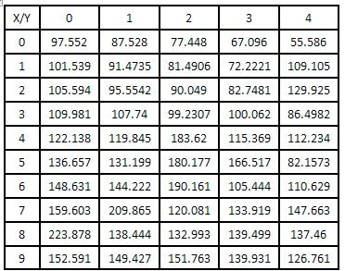

usually un-even terrain. Path planning using modified D* algorithm involving the terrain slope for cost computation is successfully demonstrated in this paper. The algorithm was simulated in C and tested with various input conditions. Path planned with modified D* algorithm produces efficient results compared to D* algorithm.
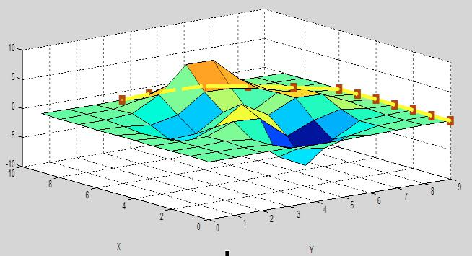

Table 7: Cost function computed based on Modified D* - cells 00 to 94
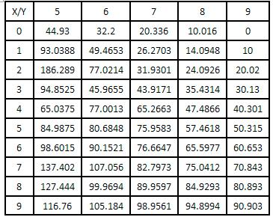

Table 8: Cost function computed based on Modified D* - cells 50 to 99
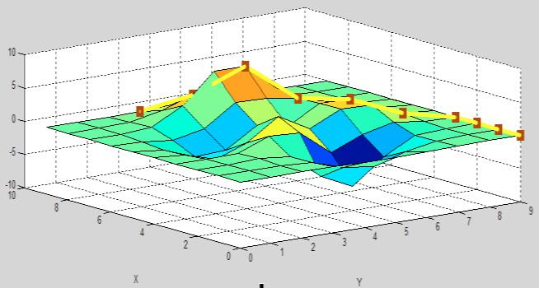

Figure 8: Path traced by Rover using D* algorithm

- CONCLUSION

D* is an efficient path planning algorithm for autonomous navigators, even for unknown environments. Real world outdoor environments are

Figure 9: Path traced by Rover using Modified D* algorithm

REFERENCES

Steven M.LaValle (2006), “Planning Algorithms’, Cambridge
University Press.

Takayuki Goto, Takeshi Kosaka, and Hiroshi Noborio (2003), “On the

Heuristics of A* or A Algorithm in ITS and Robot Path-

Planning”, Proceedings of the 2003 IEEWRSJ, InU. Conference on Intelligent Robots and Systems

GopiKrishnan S, BVS Shravan, Harishit Gole, Pratik Barve and

Ravikumar L (2011), “Path Planning Algorithms: A comparative study”, Space Transportation Systems, Trivandrum, VSSC.

Y. Koren, Senior Member, IEEE and J. Borenstein, Member, IEEE (1991) , “Potential Field Methods and Their Inherent Limitations

for Mobile Robot Navigation”, Proceedings | of the | IEEE
Conference on Robotics and Automation, Sacramento, California,
April 7-12, 1991, pp. 1398-1404.
Jorge Nieto, Emanuel Slawinski, Vicente Mut and Bernardo Wagner
(2010), “Online Path Planning based on Rapidly-Exploring
Random Trees”, Industrial Technology (ICIT), | 2010 | IEEE

International Conference , 14-17, March 2010.

Genya Ishigami, Keiji Nagatani, and Kazuya Yoshida, “Path Planning and Evaluation for Planetary Rovers Based on Dynamic Mobility Index”

IEEE/RSJ International Conference on Intelligent Robots and Systems
September 25-30, 2011. San Francisco, CA, USA

Xie Yuan, Zhou Jianliang and Wang Yong, “Dynamic Mission-level Path Planning for Lunar Rovers”, International Conference on

Control, Automation and Systems 2010 Oct. 27-30, 2010 in KINTEX, Gyeonggi-do, Korea

Anthony Stentz, “Optimal and Efficient Path Planning for partially known environment”, IEEE International Conference on Robotics
and Automation, May 1994.

Joseph Carsten and Arturo Rankin, Dave Ferguson, Anthony Stentz,

“Global Planning on the Mars Exploration Rovers: Software Integration and Surface Testing”, Journal of Field Robotics 26(4),
337–357, 2009

